Exp 5
from flask import Flask, request, render_template_string, redirect, url_for
app = Flask(__name__)
submissions = []
@app.route('/', methods=['GET'])
def form():
return render_template_string('<form method="post" action="/submit">Name: <input name="name"><button>Send</button></form>')
@app.route('/submit', methods=['POST'])
def submit():
name = (request.form.get('name') or '').strip()
if len(name) < 2:
return "Name too short", 400
submissions.append({'name': name})
return f"Thanks, {name}!"
@app.errorhandler(404)
def not_found(e):
return "404 — not found", 404
if __name__ == "__main__":
app.run(debug=True, port=3000)

Output :
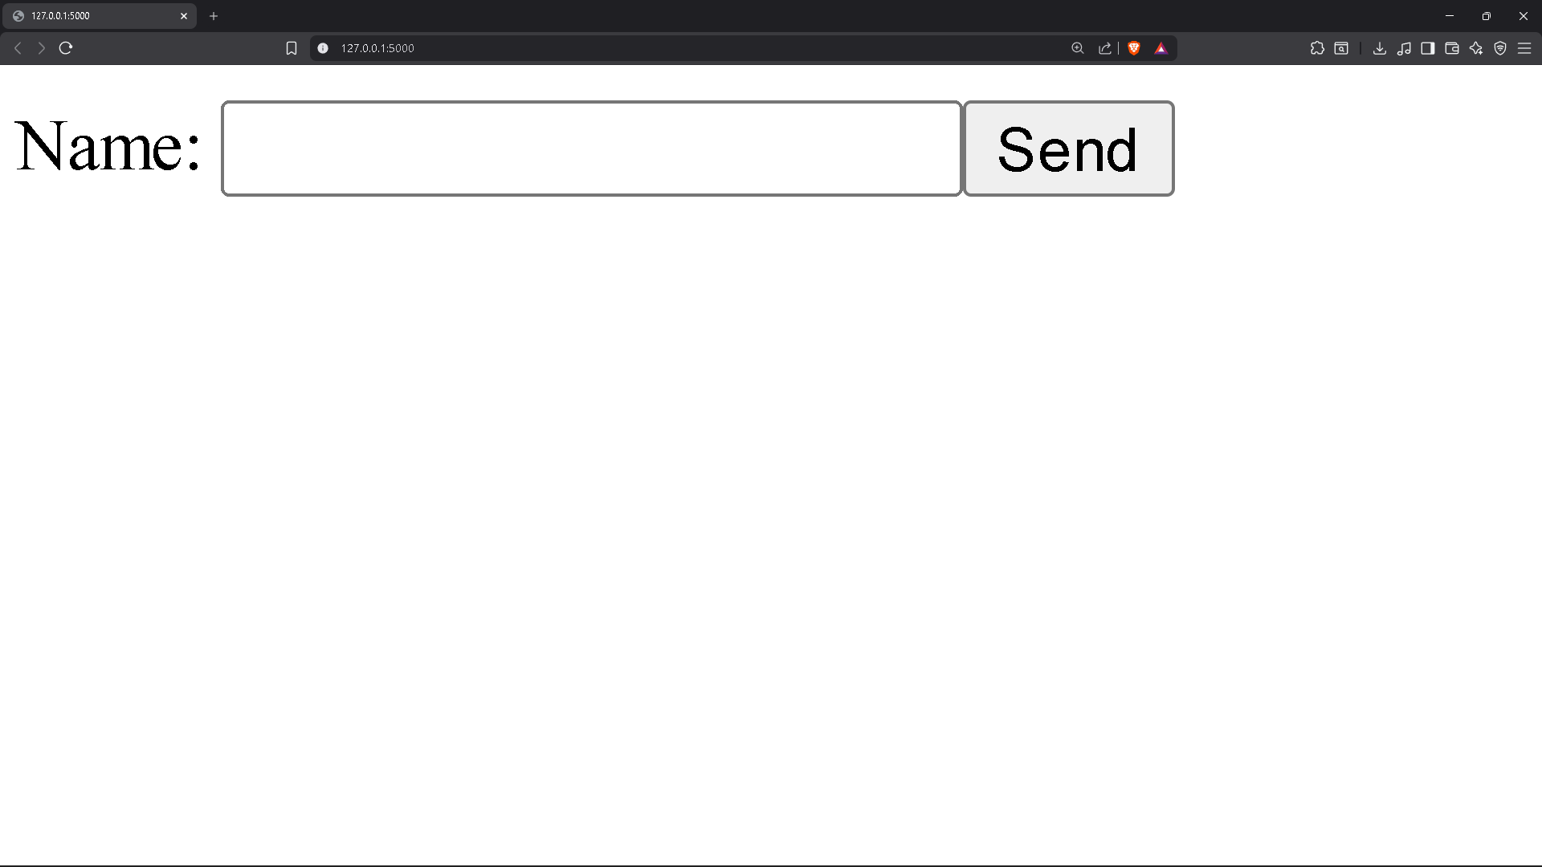
d:\WT\EXP's\Exp6>curl -i http://localhost:3000/
HTTP/1.1 200 OK
Server: Werkzeug/3.1.3 Python/3.13.2
Date: Sun, 05 Apr 2026 06:00:11 GMT
Content-Type: text/html; charset=utf-8
Content-Length: 90
Connection: close

<form method="post" action="/submit">Name: <input name="name"><button>Send</button></form>
d:\WT\EXP's\Exp6>curl -i -X POST http://localhost:3000/submit -d "name=Abcdef&email=abc123@gmail.com&message=Hello"
HTTP/1.1 200 OK
Server: Werkzeug/3.1.3 Python/3.13.2
Date: Sun, 05 Apr 2026 06:00:20 GMT
Content-Type: text/html; charset=utf-8
Content-Length: 15
Connection: close

Thanks, Abcdef!
d:\WT\EXP's\Exp6>curl -i -X POST http://localhost:3000/submit -d "name=S&email=bad&message=hi"
HTTP/1.1 400 BAD REQUEST
Server: Werkzeug/3.1.3 Python/3.13.2
Date: Sun, 05 Apr 2026 06:00:27 GMT
Content-Type: text/html; charset=utf-8
Content-Length: 14
Connection: close

Name too short
d:\WT\EXP's\Exp6>curl -i http://localhost:3000/invalid-route
HTTP/1.1 404 NOT FOUND
Server: Werkzeug/3.1.3 Python/3.13.2
Date: Sun, 05 Apr 2026 06:00:34 GMT
Content-Type: text/html; charset=utf-8
Content-Length: 17
Connection: close

404 — not found
d:\WT\EXP's\Exp6>

